

# “SPEED TESTING DEVICE”

## A MINI PROJECT REPORT

***Submitted by:***

**YOGESH O M (1NH18EC759)**

**KIRAN JANGID (1NH18EC726)**

**MEVIN FRANCIS (1NH18EC738)**

**VARUN M R (1NH18EC758)**

*In partial fulfilment for the award of the degree of*

### BACHELOR OF ENGINEERING

**IN**

**ELECTRONICS AND COMMUNICATION ENGINEERING**

**TABLE OF CONTENTS**

ABSTRACT

**CHAPTER 1**

INTRODUCTION................................................................................................................6

**CHAPTER 2**

LITERATURE SURVEY……………………………………………………………………….…….....8

**CHAPTER 3**

PROPOSED METHODOLOG……………………………………………..………….33

**CHAPTER 4**

PROJECT DESCRIPTION …………………………………………………..……………9

HARDWAREDESCRIPTION………………………………………………….................12

**CHAPTER 5**

RESULTSANDDISCUSSION……………………………………………………………36

**CHAPTER 6**

CONCLUSIONANDFUTURESCOPE….............................................……………………37

REFERENCE……..…………………………………………………………………….….38

APPENDIX…………………………………………………………………………….…..38

**LIST OF FIGURES**

|  |  |  |  |
| --- | --- | --- | --- |
| **SL**  **No** | **FIGURE**  **No** | **FIGURE DESCRIPTION** | **Page**  **No** |
| 1 | 1 | Initialization of laser and LDR | 4 |
| 2 | 2 | Survey of accidents due to rash driving | 5 |
| 3 | 3 | Circuit diagram | 7 |
| 4 | 4 | 555 timer | 9 |
| 5 | 5 | Internal design of 555 timer | 9 |
| 6 | 6 | Circuit diagram Monostable state | 12 |
| 7 | 7 | Circuit diagram of bistable state | 13 |
| 8 | 8 | Resistor | 15 |
| 9 | 9 | Variable resistor | 15 |
| 10 | 10 | Capacitor | 16 |
| 11 | 11 | Diodes | 17 |
| 12 | 12 | Pin configuration IC CD4026 | 21 |
| 13 | 13 | Internal design of IC cd4011 | 23 |
| 14 | 14 | Led bulb | 25 |
| 15 | 15 | Seven segment display | 26 |
| 16 | 16 | LDR | 26 |
| 17 | 17 | Laser | 27 |
| 18 | 18 | Switch | 28 |
| 19 | 19 | Top view of a bread broad | 29 |
| 20 | 20 | Project on completion | 34 |

**ABSTRACT**

The aim of this project is to develop a device to detect rash driving on roads and to alert the traffic authorities in case of any speed violation. Accidents due to rash driving on Roads are on the rise and people are losing their life because of others mistakes.

In the present system, to detect rash driving the police man are started to handheld radar gun and aim at the vehicle to record its speed. If the speed of the vehicle exceeds the speed limit, nearest police station is informed to stop the vehicle and to avoid the vehicle speed. This is an very easy process as after detecting one has to inform the same and a lot of time is wasted.

This system will check the speed of a vehicle using the time taken to travel between the two set points at a fixed distance. A set point consists of a pair of sensors comprising of an laser and an LDR, each of which are installed on either sides of the road.

The speed limit is set by the police man who use the system depending upon the traffic at the very traffic location. The time taken by the vehicle to travel from one set point to the other set point is calculated by the help of NE555 timer. Based on that time it then calculates the speed and displays that on seven segment displays or show the waveform . Moreover if the vehicle crosses the speed limit, a buzzer sounds alerting the police that the speed is high.

This project can be extended in future by inserting the a camera with the system which could capture the image of the number plate of the vehicle which is moving in a high speed and sends that to the traffic authorities.

**Keywords**: List of Keywords

* 5 NE555 timer IC
* 4 CD4026 IC s
* 4 7-sgment display
* Resistors
* 1 CD4011 IC s
* Variable resistors
* Electrolytic capacitors
* Ceramic capacitors
* LEDs (red ,yellow)
* Lasers
* LDR
* Piezo buzzer
* Diode(1N4148)

**Chapter 1**

INTRODUCTION

Now a days we see more accidents on roads, highways due to speed violations the drivers tents to ignore the speedometers .so, to prevent this accidents we developed speed testing devices. This speed testing device will come handy for the traffic police it will not only display the speed it will also make a alarm if the vehicle exceed the maximum speed

This device basically consist two lasers transmitter-LDR .

Where the laser should be insta 100metres apart each others .with the laser transmitter , LDR ,is placed opposite to the lasers on the sides of roads .

The system displays the time taken by the vehicle is crossing this 100meters distance with the resolution of 0.01sec from which the speed of the vehicle can be calculated

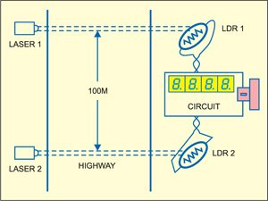

figure 1 : Initialization of laser and LDR

Speed of 40kmph the display will read 9sec (or) 900 for the speed of 60kmph will read as 600 (or 6sec)

Speed=distance /time

Distance=0.1kms

Speed=reading *0.1km/600

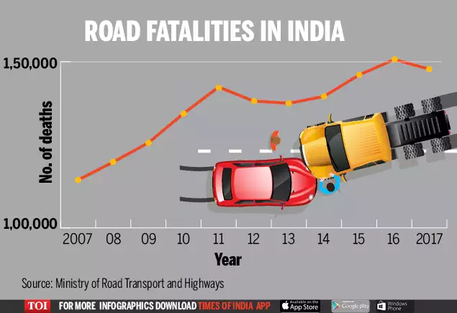

figure 2: Survey of accidents due to rash driving

As per above graph now a days accident is increasing in india to avoid this accident we are developing the above project.

**Chapter 2**

LITERATURE SURVEY

1.Dinesh Mohan, Omer Tsimhoni, Michael Sivak, Michael J Flannagan Road safety in India: challenges and opportunities –Repost numberUMTRI-2009-1 <http://www.deepblue.lib.umich.edu>

2. Manisha Ruikar, National statistics of road traffic accidents in India, Journal of Orthopaedics, Traumatology and Rehabilitation, 23 Sep. 2013, vol. 6, issue 1, pp. 1-6

3. Daniel Brookoff, Charles S. Cook, Charles Williams, and Calvin S. Mann, Testing Reckless Drivers for Cocaine and Marijuana, The New England Journal of Medicine, Aug. 25, 1994, pp. 518-522

4. Jiangpeng Dai , Jin Teng , Xiaole Bai , Zhaohui Shen,and Dong Xuan Mobile phone based drunk driving detection in Pervasive Computing Technologies for Healthcare (Pervasive Health), 2010 4th International Conference . <http://ieeexplore.ieee.org>

5. Available on [https://medvinlaw.com/reckless-driving-in-virginia-while-intoxicated-or-with-elevated-bloodalcohol-level-bac-new-2013-case-law/]

6. Lafayatte police department Advanced roadside interview techniques for petrol officers.

**Chapter 3**

Project description

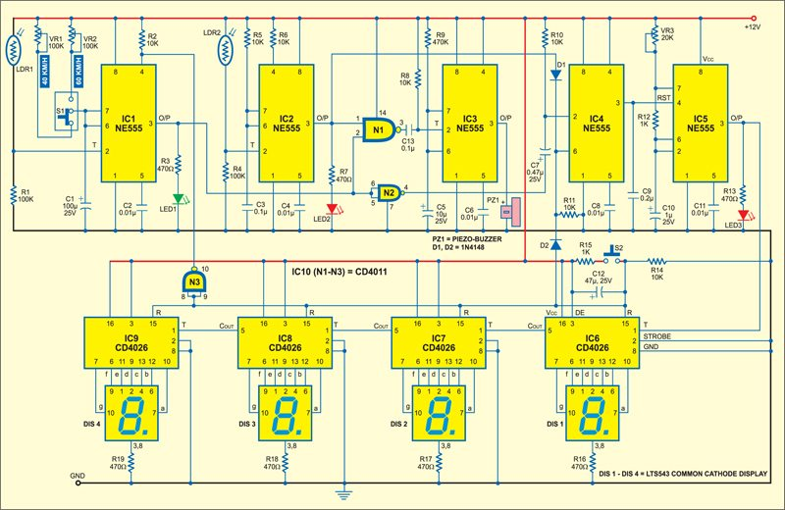

figure 3 : circuit diagram

The circuit is mainly consist of

* 5 NE555 timer IC
* 4 CD4026 IC s
* 4 7-sgment display
* Resistors( 470 Ω,10k Ω,100k Ω,470 Ω k,1 Ω k)
* 1 CD4011 IC s
* Variable resistors 100k,20k
* Electrolytic capacitors(1000μF,47μF,1 μF)
* Ceramic capacitors(0.1 μF,0.01 μf,0.1 μf)
* LEDs (red ,yellow)
* Lasers 2
* LDR 2
* Piezo buzzer
* Diode(1N4148)

IC 1,IC 2,IC 3,will be act as monostables, where IC 1 serves as count start mono ,IC 2 count stop mono ,IC 3 as speed detector mono ,IC3 is controlled by IC 1and IC 2 outputs .IC 4 serves as bistable set-reset which is also controlled by IC s of 1 and 2.IC 4 in turn controls switching of IC 5 .where IC 5 serves as a stable state

Where time period if IC1count start monostable multivibrator is adjusted by using VR(or)VR2(100k).

And capacitor C1.for 40kmph limit the time period is set for 9sec using VR1 where for 60kmph the period is set for 6sec.

The junction of LDR1 and resistor R1 is coupled to pin 2 of IC 1.jenerally the laser light is used to continuously fall on LDRs and LDR will provides low resistance to pin 2 of IC .IC 1 goes low to trigger the monostable as result, the output 3 goes high for the preset 9-6 sec and LED 1 glows to indicate it reset pin 4 is controlled by the output of NAND gate at power on.

For IC 1 monostable is triggered as same as IC 1 when the vehicle passes, laser beam incident on LDR 2 to generate low pulse to stopping the count for using the speed detection LED 2 glows for the duration of time for which pin 3 of IC 2 is high.

the outputs of IC 1 and IC 2 are fed in to the input of NAND gate when the output of IC and IC

goes high simultaneously (the vehicle as passed the preset speed limit, output pin 3 of NAND gate goes to low trigger monostable of IC3 .output of IC 3 is used for driving piezo buzzer.

which alerts the operator of speed limit violation resistor R9 and capacitor 5 decides the time period of for which the piezo buzzer sounds the output of IC 1 trigger the bistable (IC4) through gate N2 at leading edge of count start pulse. When pin 2 if IC 4 goes low(0) the high output at its pin 3 enables a stable clock generator of IC 5 since the count stop

where the output(pulse) of IC2 which is connected to pin 6 of IC 4 through a Diode it resets clock generator of IC 5.where IC 1 can be reset though diode as power on IC 5 is astable multivibrator whose time period is controlled by preset(k), resistor(1k )and capacitor (μF)and the output of IC 5 is fed to clock pin(IC CD4026) where CD 4026 is a 5 stage- Johnson decade counter .

where the Johnson decade counter will decode the output and convers the Johnson code 7segment decoded output for driving display 1 .the counter advances by one count at the positive clock of signal transition .the carry out signal from CD4026 provides one clock after every 10 clock inputs to clock the succeeding decade counter in multi decade counting change. This is achieved by connecting pin 5 to pin 1 of each CD 4026 and connected from pin 1 to next CD 4026

The high reset signal clears the decade counter to zero count pressing switch to providing to reset signal to pin 15 of all CD4026 IC s capacitor (47 μF)and resistor generates the power on signals where the output of CD4026 is connected to 7segment display for proper output .

where the output of CD4026is connected to 7 segment display through resistors (470 ohm) which oppose the current.

**HARDWARE DESCRIPTION**

**3.1.1**

**NE555 TIMER**

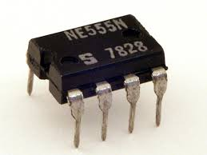

figure 4:555 timer

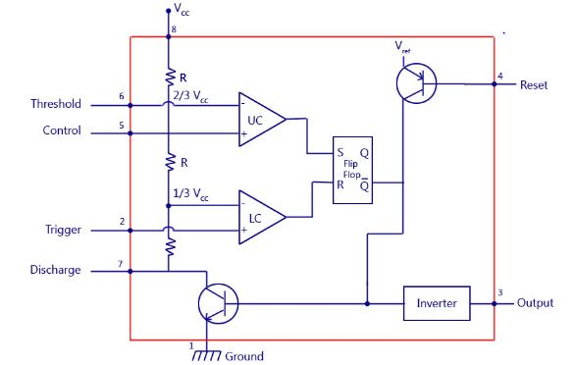

figure 5:internal design of internal timer

555 timer is used in every electronic circuit . A 555 timer works as a flip flop  (no in put one clock is enough to get the output), it has some identical set of configurations. Where it consists of 23 transisters,2 diodes ,16 resistors.

Some of the major features of the 555 timer are,

* It operates from a wide range power(voltage) ranging from +5 Volts to +18 Volts supply voltage.
* Absorbing 200 mA of load current.
* The external components should be selected properly so that the timing duration can be made into several seconds along with the frequencies exceeding several hundred kilohertz.
* The output of a 555 timer can drive a transistor-transistor logic (TTL) due to its high current across the output.
* It has a temperature stability of 50 parts per million (ppm) per degree Celsius change in a temperature which is equivalent in percentage is 0.005 % °C.
* The duty of a cycle of the timer is adjustable depending of a need.
* Also, the maximum power dissipation per cycle in NE555IC is 600 mW and its trigger and reset inputs has logic compatibility.

The 555 timer was invented by Hans Camenzind in the year 1970. The 555 timer is an integrated circuit used in a variety of pulse generation, timer and oscillator applications. The IC 555 timer is called a IC because it can be used for pulse generation with respect to time.

The 555 timer has three main operation modes :

* Bistable
* Monostable
* Astablemode

BISTABLE MODE :

The trigger and the reset pins are connected to VCC through two resistors and hence they are always high . There are two push buttons which are connected between these pins and GND thereby the input state will be low . In the beginning the value of the comparators will be zero, hence the flip flop output as well as the output of 555 will be zero . If we press the push button, the state at the input trigger will become low , so the comparator output now will be high and makes the flip flop output go low . The output of this will be inverted and the final output will be high .The output will remain high even if the trigger push buttons is not being pushed because the flip flop inputs R and S will be zero thereby it won’t change the previous state. If you need the output to be low then press the reset push button, which resets the flip flop and the entire IC .

MONOSTABLE MODE :

The Trigger inputs are being held high by connecting VCC through a resistor , which means that the trigger comparator output will be zero to the S input of the flip flop . On the other hand, the threshold pin is low which makes the comparator output zero . Here the threshold pin is low because the output og the flip flop is high , which the discharge transistor active so the voltage coming from the source foes directly to GND.

If you would like to change the output state of the 555 timer we need to press the push button . that in return will ground the trigger pin and output of the input state will be zero . At the same time we can see that the discharge transistor is turned off so now C1 will start charging .

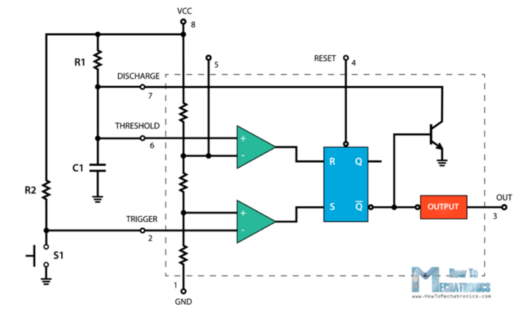figure 6:circuit diagram of monostable state

ASTABLE MODE :

In this state the IC becomes an oscillator or is also called as the FREE RUNNING MULTIVIBRATOR . It doesn’t have a stable state and continuously keeps changing between high and low application Of any external trigger .

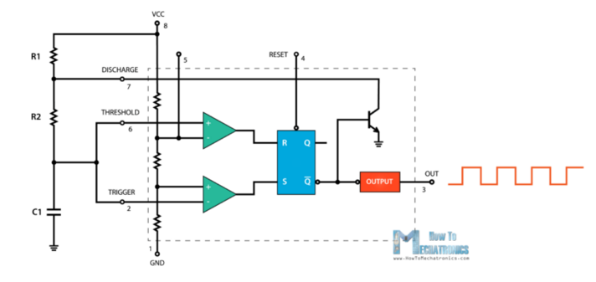

Figure 7:circuit diagram of bistable state

We just need two resistors and one capacitor . There is no need of any external trigger pulse as the threshold pins are connected to each other . The voltage source will start charging the capacitors through the resistors R1 and R2 , and the discharge transistor is closed . The output at this time is high . We can calculate the time when the output is high and low using the formula’s . we if sum the high the low time we can get the period of one complete cycle .

The maximum frequency of the time is 555 oscillator . To get the 555 operate in its highest frequency we should make sure it is continuously retriggered at the instant when the output changes state from high to low , low to high.

**3.1.2RESISTORS**

Obstruction is the restriction offered to the current. It is estimated in Ohms (). Which is likewise decided in an OHMs law .where to restrict the current on the off chance that we increment or reduction the estimation of resistor we can accomplish that.

Where the estimation of electrical protections relies upon materials, measurement, and the temperature of the conduit. All conductors should required a specific measure of opposition, since no conductor is actually effective. To control the current in a reasonable way, we use resistors. Electronic circuits use protection from control the progression of current.

Resistors are separated in to two fundamental branches :

• Fixed resistors.

• Variable resistors.

. In fixed resistors, the estimation of an obstruction is fixed and can't be changed . In factor resistors, the obstruction worth can be changed by an agent handle. It tends to be separated into (a) Carbon creation (b) Wire wound (c) Special sort. The kind of resistors utilized in our activities is carbon type and furthermore ¼ watt. The opposition esteem is typically demonstrated by observing shading groups. Every obstruction has four hues, one of the band is resilience band on either side which will be gold or silver, this is called fourth band and shows the resistance, others three band will give the estimation of opposition (see table). For instance if a resistor has the accompanying stamping on it state yellow, violet, dark colored, gold. Contrasting these shaded rings and the shading code, its worth is 470000ohms or 470kilo ohms and its resilience is ±5%. Resistor comes in different sizes (Power rating). The greater, the size, the more power rating of 1/4 watts. The four shading rings on its body discloses to us the estimation of resistor esteem as given beneath.

***COLOURS CODE***

Black 0

Brown 1

Red 2

Orange 3

Yellow 4

Green 5

Blue 6

Violet 7

Grey 8

White 9

Where it is also called as BBROY of great britan has a very good wife wearing silver and gold.

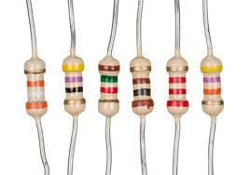

Figure 8:resistor

**3.1.2.1VARIABLE RESISTORS**

Variable resisters are resisters in which resistance value can be changed up to the certain value, with in a pre determined range.

These resistors are three terminal devices. In which the Two terminals are fixed while the third one is connected in such a way to change the value of the resistors, changing the value of resistance between last terminal Variable resistance ,which also change the value of resistors the are also called as potentiometer.

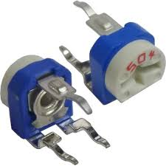Figure 9 : variable resistor

3.1.3 CAPACITORS

Capacitors are the electronic segment whose capacity is to store charges(electrons) and afterward discharge it at whatever point it need. To comprehend the idea of capacitance, consider a couple of metal plates which all are set close to one another without contacting. In the event that a battery is associated with these plates the positive post to one and the negative shaft to different, electrons from the battery will be pulled in from the plate associated with the positive terminal of the battery. On the off chance that the battery is, at that point detached, one plate will be left with an abundance of electrons, the other with a deficiency, and a potential or voltage distinction will exists between them. These plates will go about as capacitors. Capacitors are of two kinds: - (1) fixed sort like ceramic,electrolytic these names allude to the material they are made of aluminum foil. (2) Variable type like group condenser in radio or trimmer. In fixed kind capacitors, it has two leads and its worth is composed over its body and variable sort has three leads. Unit of estimation of a capacitor is farad meant by the image F. It is an extremely huge unit of capacitance.

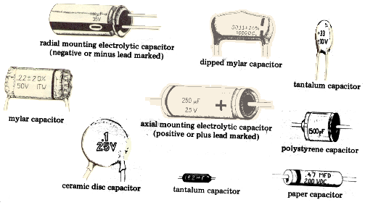

Figure 10:capacitor

Little unit capacitor are pico-farad signified by pf (Ipf=1/1000,000,000,000 f) Above all, if there should arise an occurrence of electrolytic capacitors, it's two terminal are set apart as (- ) and (+) so check it while utilizing capacitors in the circuit in right heading. Mix-up can crush the capacitor or whole circuit in operational.

**3.1.4DIODE**

The easiest semiconductor gadget is comprised of a sandwich of P-type semiconducting material, with contacts gave to associate the p-and n-type layers to an outer circuit. This is an intersection Diode. In the event that the positive terminal of the battery is associated with the p-type material (cathode) and the negative terminal to the N-type material (Anode), a huge current will stream. This is called forward present or forward one-sided.

On the off chance that the associations are turned around, a next to no present will stream. This is on the grounds that under this condition, the p-type material will acknowledge the electrons from the negative terminal of the battery and the N-type material will surrender its free electrons to the battery, bringing about the condition of electrical balance since the N-type material has no more electrons. In this way there will be a little current to stream and the diode is called Reverse one-sided.

In this way the Diode enables direct current to pass just one way while blocking it the other way. Power diodes are utilized in concerting AC into DC. In this, current will stream uninhibitedly during the principal half cycle (forward one-sided) and for all intents and purposes not in any manner during the other half cycle (invert one-sided). This makes the diode a compelling rectifier, which convert air conditioning into throbbing dc. Signal diodes are utilized in radio circuits for identification. Zener diodes are utilized in the circuit to control the voltage.

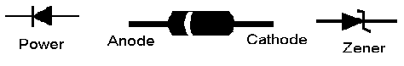

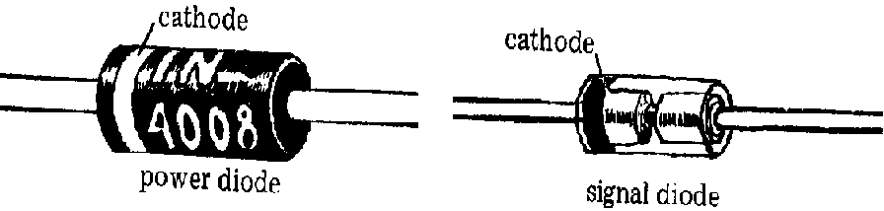

Figure 11:diode

Some common diodes are:-

1. Zener diode.

2. Photo diode.

3. Light Emitting diode.

FEW APPLICATIONS OF DIODE ARE :

* They are as rectifier
* In the clipping circuit
* In logical gate
* In reverse current protection

|  |  |  |
| --- | --- | --- |
| PIN NUMBER | **3.1.5iCCD4026**  PIN NAME | DESCRIPTION |
| 1 | Clock (CLK) | The checking happens when this clock beat goes high , this stick is regularly associated with 555 clock or other uC to create a heartbeat |
| 2 | Clock Inhibit (INH) | Clock Inhibit (INH) Connected to the Ground (low) of the circuit, to empower clock stick |
| 3 | Enable Input (DEI) | Enable Input (DEI) This stick is associate with +5V (high) to empower the yield pins (Out A to Out G) |
| 4 | Enable Output (DEO) | Enable Output (DEO) This is a yield which consistently remains high, this stick will be just if more than one CD4026 IC is utilized (fell) |
| 5 | Divide by 10 (CO) | Divide by 10 (CO) This is the extend yield stick; it delivers a heartbeat subsequent to checking till 9. This stick will be just if more than one CD4026 IC is utilized (fell) |
| 6,7,9,10,11,12,13 | Out A,B,C,D,E, F,G | Out A,B,C,D,E, F,G These are the decoded yield pins which should associated with 7-Segment show.. |
| 8 | Ground | Ground The ground stick ought to be associated with ground of circuit |
| 14 | Not 2 out (UCS) | Not 2 out (UCS) This is Ungated C section stick. This is a yield stick which will be infrequently utilized when division is required. |
| 15 | Reset | Reset This input stick when made high (+5V) will reset the check to 0. |
| 16 | Vcc | Vcc This stick controls the IC, regularly +5V is utilized. |

[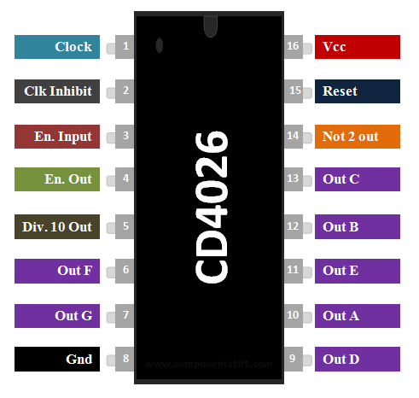](https://components101.com/sites/default/files/component_pin/IC-CD4026-Piinout.png)

Figure 12:pin configuration ic cd 4026

Compact disc 4026 comprise of a 5-organize Johnson decade counter and a yield decoder which changes over the Johnson code to a7-section unravel yield for driving one arrange in a numerical showcase .these especially favorable in show applications where low control dissemination as well as low bundle checks are significant. Info is CLOCK INHIBIT, regular yields are CARRY OUT and the seven decoded yields (a, b, c, d, e, f ,g). Extra sources of info and yields for the CD 4026 incorporate DISPLAY ENABLE information and DISPLAY ENABLE and UNGATED "C-SEGMENT" yields. A high RESET sign clears the decade counter to its zero check. The counter is propelled one tally at the positive clock signal progress if the CLOCK INHIBIT signal is low. Counter headway by means of the clock line is restrained when the CLOCK INHIBIT signal is high. The CLOCK INHIBIT sign can be utilized as a negative-edge clock if the clock line is held high. Antilock gating is given on the JOHNSON counter, along these lines guaranteeing legitimate tallying grouping. The CARRY-OUT (Count) signal finishes. The cycle each ten CLOCK INPUT cycles and it is utilized to clock the succeeding decade straightforwardly in a multi-decade checking chain. The seven decoded yields (a, b, c, d, e, f, g) light up the best possible sections in a seven fragment show gadget utilized for speaking to the decimal numbers 0 to 9. The 7-segmentoutputs go high just when the DISPLAY ENABLE IN is high.

### 3.1.6 IC CD4011

[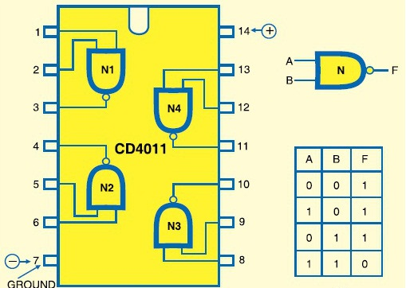](https://www.google.co.in/url?sa=i&rct=j&q=&esrc=s&source=images&cd=&ved=2ahUKEwi4-Nbg8sDlAhWWfH0KHTeZC5AQjRx6BAgBEAQ&url=https://www.gadgetronicx.com/working-of-cd4011-ic/&psig=AOvVaw2UaraCkfnXFVJzhYbxR9DI&ust=1572418828494865)

Figure 13internal design if ic cd 4011:

Where this ic same as nand gate but it is made up of cmos .

**IC CD4011 Quad 2-Input NAND Buffered B Series Gate**

**General Description**

The CD4011BC are solid Complementary metal, Oxide Semiconductor (CMOS) incorporated circuits built with both N-and P-channel upgrade mode transistors. This IC is additionally called quad since it is comprised of 4 NAND entryways. They have equivalent source and retaining current abilities and adjust to standard B arrangement yield drive. The gadgets additionally have cushioned yields which improve move characteristics(input versus out put) by giving extremely high increase. All sources of info ensured against enduring release with diodes to VDD and VSS.

Highlights

• Low Transistor – Transistor rationale control rang.

• 5V–10V–15V parametric appraisals

• yield qualities are symmetric.

• where the ic can watch the current of 1A at 15v at a full temperature.

**3.1.7 LED**

Light emitting diode(LED)

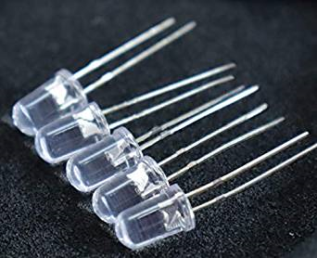

Figure 14:led bulb

A **light-emitting diode** (**LED**) is a source of light (semiconductor) that emits light when the current flows through it. In the semiconductor holes recombine with electrons, releasing energy in the form of light(photon).

**3.1.8 SEVEN SEGMENT LED DISPLAY**

**LTS543** is common cathode 7- segment LED display. These display devices are used in application to display the number. where the observer is within 6 m of display. This type of red or green LED fits into standard dip sockets with 1.52 cm pin row.

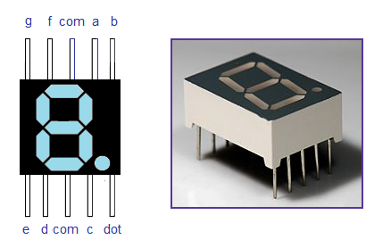 Figure 15:seven segment display

**3.1.9 LDR**

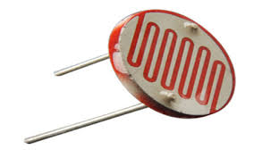 Figure 16:ldr

Light needy resistors, LDRs or photoresistors are regularly utilized in circuits where it is important to identify the nearness or the degree of light. Where in our task it is the principle factor which detects the speed

Hardware opto sensors are gadgets that change their electrical qualities, within the sight of unmistakable or imperceptible light. The best known gadgets of these sorts are the LDR (Light ward resistor), the photodiode, and the phototransistor.

LDR activity depends on the way that the conductive opposition of a film of cadmium sulfide (Cds) fluctuates with the force of light falling on the essence of the film. This obstruction is exceptionally high under dim conditions and low under splendid conditions. The gadget comprises of a couple of metal film contacts isolated by a snake-like track of cadmium provided film, intended to furnish the most extreme conceivable contact region with the two metal movies.

The structure is housed in a tar case, to give outer light to ceaselessly occurrence . LDRs are delicate , ease, and promptly accessible in certain local people. They have great power and Voltage dealing with, like those of a customary resistor.

Their lone noteworthy deformity is that they are genuinely moderate acting, taking tens or several milliseconds to react to unexpected changes in light level. Helpful down to earth LDR applications incorporate light-and dull enacted switches and cautions, and intelligent smoke alerts and so forth.

**3.1.10 LASER**

[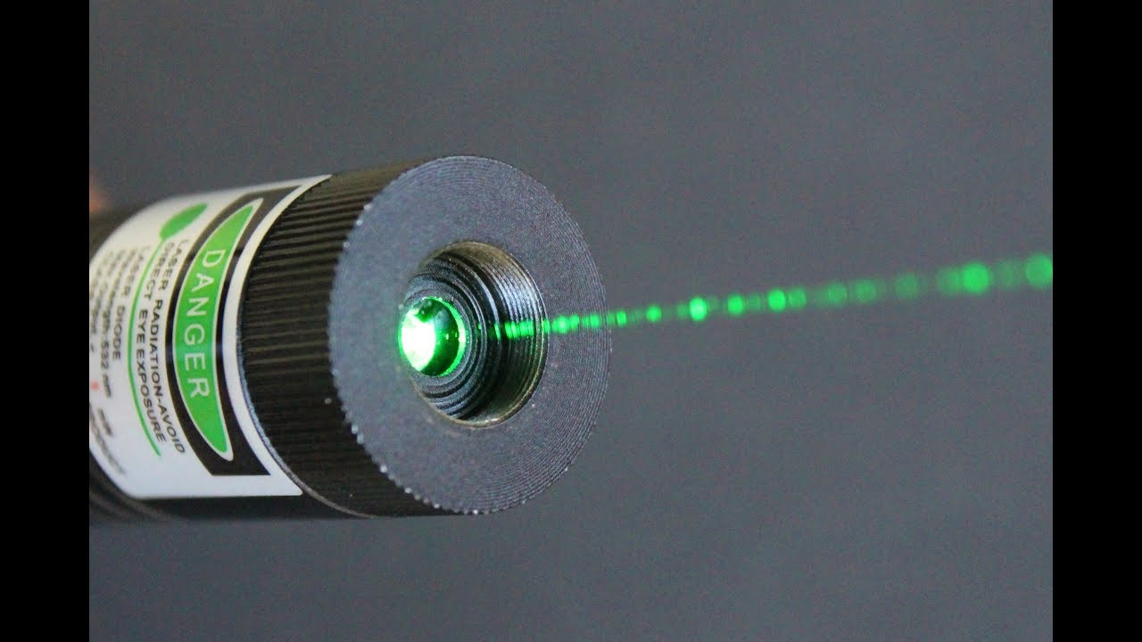](https://www.google.co.in/url?sa=i&rct=j&q=&esrc=s&source=images&cd=&ved=2ahUKEwiAg-bK-cDlAhW66nMBHcJfCSYQjRx6BAgBEAQ&url=https://www.youtube.com/watch?v=AZqPLvF0kZ0&psig=AOvVaw3kvdoj8z3Wu-MBCgsUlNC0&ust=1572420655036205)

Figure 17:laser

Where the beam of light having a high intensity. The monochromatic light with a single beam.

**3.1.11 PUSH TO ON SWITCH**

They are utilized for makes the association just when switch is squeezed. On discharging button the association must be separate.

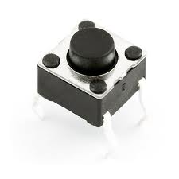

Figure 18:push on switch

3.1.12 Breadboard**:**

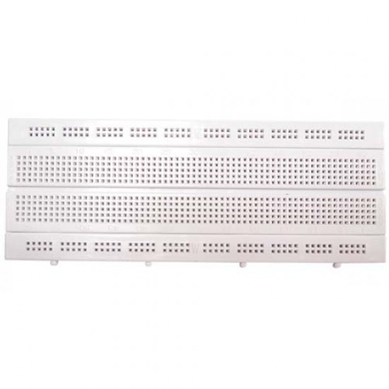

Figure19 : Top view of Breadboard

A breadboard is a bind less gadget for brief model with hardware and test circuit structures. Most electronic segments in electronic circuits can be interconnected by embeddings their leads or terminals into the openings and afterward making associations through wires where fitting. Breadboards are utilized for testing and exploring different avenues regarding electronic circuits. You will discover them amazingly advantageous in light of the fact that they are no requirement for patching inside, or remotely and you need to simply connect the parts to the little openings that are given on the breadboard. In any event, when there is blunder in arrangement of the parts they can be separated and reattached to the board appropriately.

**Chapter 4**

Proposed methodology

Assemble the circuit on PCB or bread board .the actual size of speed testing device is very small

And check the contunity before operation by using multimeter to get the correct output

If the continuity is correct which is indicated by multimeter then provide he voltage supply of 12volts to the divice then the device will be on in the circuit we use the long wires for connecting LDR on breadboard or PCB .

So connecting 2 LDR s which is 100mts apart each other on side of the road .place the 2 laser transmitter on the other side of the road which is made to continually incident the light beam on the LDR . where the laser reflect directly on the LDR s .we can reset the circuit by pressing switch ,so it will show -0000 .

By turning on the other switch resetting the speed limit of 60kmph for the roads .

When the vehicle passes the first laser light which refracts the light beam falling on the LDR which will trigger IC 1 which is the monostable. And the output of IC 1 is high for the time set to cross 100mtrs with the selected speed and LED 1 start glows on that time .

When the vehicle passes the second laser light where the vehicle crosses the second laser with 0.06secs . which is used to set for 60 kmph .and the output of IC 2 will be high and LED 2 start glowing at the time.

The piezo buzzer sounds an alarm which the vehicle crosses the distance between the laser set up more than the fixed speed limit .

The counter will be active(Johnson counting) start counting when the light beam falling on LDR is disturb until when the second light beam start falling on LDR.

The time taken by the vehicle to interest both the light beam is displayed common cathode seven segment display. For setting the 40kmph the device is reset and the time taken by vehicle to intersect the laser beam should take a time 0.09secs.

If the vehicle exceed the speed it will alarm by piezo buzzer.

For 60kmph the frequency set by NE555 IC will be 100Hz. If the seven segment display displays less than 600. It means the vehicle has reached more than 60kmph .

For checking the speed for other vehicle it should be reset.

Note : it is applicable for only one vehicle at a time. No two vehicle speed can be determined.

**ADVANTAGE AND DISADVANTAGE OF SPEED TESTING DEVICE**

**ADVANTAGES**

* Prevents accidents which is the main problem nowadays.
* Helps the driver to maintain the required speed.
* If the driver exceeds the speed limit ,a beep sound will alert him indicating that he is over speeding.
* A simple concept with a dynamic idea.

**DISADVANTAGES**

* Very expensive when used on a larger scale.
* Requires a clear line of sight.
* Speed decreases with distance.
* Limited service area.
* Trouble shooting can be difficult.

**Chapter 5**

**RESULT**

Thus the project(system) has tested the speed of a vehicle. when the vehicle is passed through the two pairs of transmitter-LDR pairs. Here it can only check the speed of a single vehicle only.

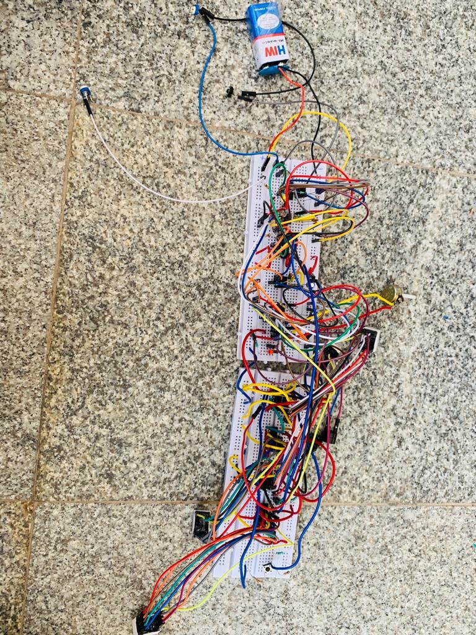

Figure 20:project on completion

**Chapter 6**

**FUTURE SCOPE AND CONCLUSION**

**CONCLUSION**

Here we implemented the “SPEED TESTING DEVICE” from point of view of safety on the road.

We feel that if mega highway is supported with such on faithful system then it will not only help to maintain the traffic rules also reduces accident. As circuit is easy but little difficult to construct and one man can handle the system efficiently.

**FUTURE SCOPE**

* This kit be still extended to speed checking of multiple vehicles by using microcontroller.
* This can also be extended to count the number of vehicles.
* The design for sending a message when an accident occurs can be done by this by installing it in a accident prone zones with some necessary add-ups.
* It will maintain the softy of human life on the road.
* It can also be used on the bridge for the control of the speed.
* It can be used on the highways, roads, highway tollgates .

**REFERANCES**

* [www.alldatasheets.com](http://www.alldatasheets.com/)
* [www.digikey.com](http://www.digikey.com)
* [www.wikipedia.com](http://www.wikipedia.com/)
* [www.electronicslab4u.com](http://www.electronicslab4u.com/)

**Appendix:**

* NE555 timer IC-5
* CD4026 IC s -4
* 7-sgment display-4
* Resistors( 470 Ω,10k Ω,100k Ω,470 Ω k,1 Ω k)-19
* CD4011 IC s-1
* Variable resistors 100k,20k-3
* Electrolytic capacitors(1000μF,47μF,1 μF)-4
* Ceramic capacitors(0.1 μF,0.01 μf,0.1 μf)-7
* LEDs (red ,yellow)-2
* Lasers - 2
* LDR -2
* Piezo buzzer-1
* Diode(1N4148)-3